## REPORTS

The Reports section includes all available text-based reports, such as: H&P’s, consults, ED notes, office visits, operative notes, radiology reports, imaging studies, and miscellaneous correspondence regarding the patient.

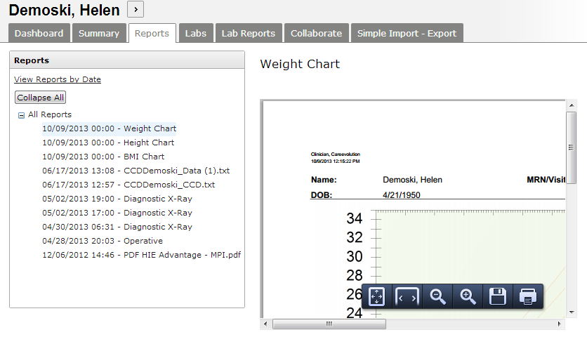

Reports are divided by category. Each category can be expanded by clicking the (**+**) next to the category name. Within categories, reports are shown in order by date with the most recent report shown first.

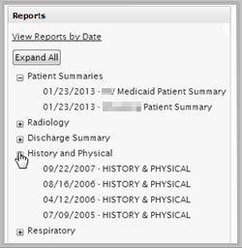

To display the text of the report, click the title. The contents will be displayed to the right of the list.

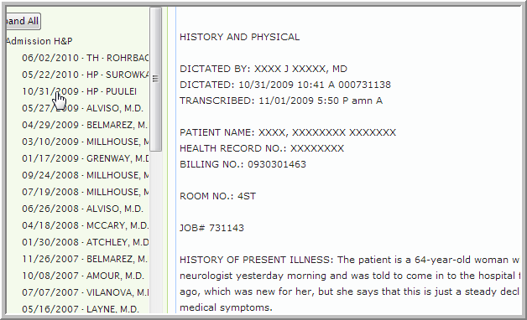

If you prefer to view reports in chronological order rather than by category, click **View Reports by Date** above the list of reports on the left. The **Expand All** buttonreveals all categories or time periods.

